**Web API manual**

It’s a simple SpringBoot application with a standard maven build. Application contains 4 endpoints which cover all cases described in task. Please find request examples below:

1. **Post creation:** (http://localhost:8080/post)

{

"user" : "testUser",

"msg" : "test 1"

}

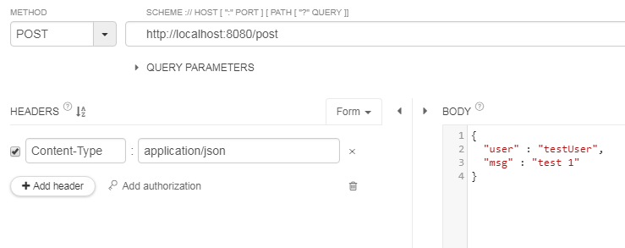

1. **Following user** (http://localhost:8080/follow?user1=alximic&user2=testUser2)

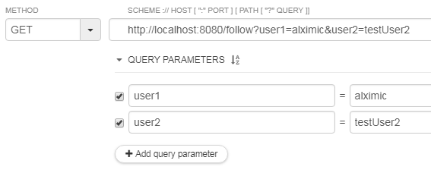

1. Get user all posts: (http://localhost:8080/getUserPosts?user=alximic)

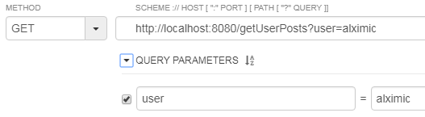

1. Get posts of all users are followed by given one

(http://localhost:8080/getFollowersPosts?user=alximic)

